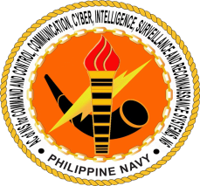HEADQUARTERS PHILIPPINE NAVY

**OFFICE OF THE AC OF NS FOR C4ISR SYSTEMS, N6**

Naval Station Jose Andrada

2335 Roxas Boulevard, Manila

From: Chairman, TWG for Cyber Laboratory and SOC Project

To: **Flag Officer in Command, Philippine Navy**

(Attn: AC of NS for Intelligence, N2)

Subj: Comments to the Memorandum of N6 to Review and Re-assess the Cyber Laboratory and Security Operations Center Project (CLSOC) Project, Request for

Reference: Memorandum from N6 Subj: Review and re-assessment of Cyber Laboratory and Security Operations Center Project (CLSOC) dated 29 June 2020

1. Above reference pertains to the memorandum of N6 to the TWG for CLSOC project to conduct review and re-assessment of the technological capabilities programmed under this project. The assessment aims to re-validate the desired end-state for the project and its strategic importance in the overall cyber defense capability requirement for the Philippine Navy.
2. The memorandum also requires the re-assessment of other similar and emerging cyber technologies that can supplement the desired capability for the project.
3. In view hereof, the TWG respectfully requests your comments and inputs on the following technologies that falls within the competence and expertise of your office:
   1. Cellular Phone Monitoring; and
   2. IMSI Catcher
4. For consideration.

**JAMES MARTY D MINGUILLAN**

CDR PN